Contents | LIST OF CHAPTERS

Chapter 1

1. Introduction to the Problem··········································································································11

2. A Brief Sketch of Selected 20th-Century Historical Issues··························································13

2.1. Society, Economy, Politics and Environment·······································································13

2.2. Korea’s Environmental Movement·······················································································18

3. The Waste Problem, c. 1990~1994·······························································································20

The Enormity of the Problem········································································································25

1. Selected Forces Generating Major Change in Korea, 1909~1994···············································26

2. Paying a Fair Price························································································································28

3. Evolution of the Legal and Administrative Framework Regarding Waste··································30

The Function and Meaning of the Volume-based Waste Fee System··········································33

1. Changes on Many Levels··············································································································34

2. The Situation Comes to a Head ···································································································35

Chapter 2

Chapter 3

Introduction:

At first glance, the story of Korea’s Volume-based Waste Fee System (VBWFS) appears simple: as Korea underwent rapid economic development during the last third of the twentieth century, millions of formerly poor citizens became prosperous, consumed more, and thus generated ever-increasing volumes of waste. The country’s new consumption habits overwhelmed the existing waste-management infrastructure, creating a looming, potentially horrific environmental crisis. Officials within the relevant government agencies observed how certain other countries had dealt with such issues.

The complexity and scope of the multi-faceted waste problem was enormous. It encompassed a vast production side that included industrial, construction and business waste, as well as the packaging materials provided with many consumer goods. It also incorporated a huge consumption side that was complicated by traditional food and eating habits, urbanization and verticalization of living space, newly acquired habits of consumption, and the citizens’ sense of entitlement to free or nearly-free waste removal and treatment. Infrastructure issues were quite vexing, especially the obsolescence and impending exhaustion of Korea’s landfills. Powerful “not-in-my-backyard” or NIMBY sentiment got squarely in the way of developing new sanitary landfills and waste incineration plants.







* Korea’s Environmental Movement:
* The relationship between the evolving environmental movement, government agencies, ordinary citizens, democratization, and later “democratic consolidation,” became ever denser during the ensuing decades.
* Many of the organizations that took root during the late 1980s expressed strident ideological positions, inspired by such statements as the Pollution Research Institute’s 1986 Anti-pollution Declaration, which asserted in no uncertain terms that
  + Pollution represents the integrated problem of all contradiction in our society. Pollution, the product of monopoly, oppression, and the division of the Korean Peninsula, destroys our life, consciousness, and the fatherland we stand on…. The termination of the anti-popular [Chun] regime, which imports the pollution industry on behalf of multinational corporations and allows the pollutions emission of monopoly capital, is the shortcut solution for the problem of our country…. Democratization has an inseparable relationship with the solution of the pollution problem.
* As more and more Koreans earned the disposable income needed to consume the goods deemed essential for an affluent middle-class lifestyle, they generated a staggering amount of garbage that existing methods and infrastructure could no longer handle effectively.
* **The Waste Problem**
* As Korea’s mass-consumption society emerged full-blown after 1990, the trash problem only continued to grow. Some of the statistics cited by Kim and Kim seem ambiguous. For example, according to a table taken from the Dong-A Ilbo newspaper in 1966, total waste (municipal plus industrial) generation increased from 145,374 tons per day in 1990 to 158,376 tons per day the following year, then declined to a low of 141,383 tons in 1993 before bouncing back to 147,049 tons per day in 1994. But over the same four-year period, per capita generation fell from 2.3kg per day to 1.3kg per day. Comparisons of Korea to other countries are less ambiguous: with regard to municipal waste in 1988, Koreans discharged 1.8kg per person per day, while in the U.S. it was 1.3kg; in Japan 1.0kg; in the U.K. and Germany, 0.9kg. The food-waste comparison is at least equally striking: Korea—0.52kg; Japan—0.37kg; Germany—0.27kg; and U.K.—0.26kg.
* Leaving aside the question of pre-VBWFS weight measurements, the impact of Korea’s newfound culture of consumption requires consideration. Kim and Kim explain the food-waste situation in terms of both traditional habits and those that emerged with the post- Miracle consumption patterns, whereby Koreans tend to serve excessive amounts of food at home and in restaurants as a sign of hospitality. Also, preparation of traditional Korean foods such as kimchi generates “a lot of vegetable waste.”36 More troubling in the realm of the new consumption is the large-scale increase in other municipal organic wastes such as paper and textiles, along with inorganic wastes containing harmful substances such as batteries, light bulbs and plastics—ubiquitous in home appliances. Add to the mix disposable razors, toothbrushes, plastic bags, wooden chopsticks, wet paper towels, paper cups, other paper products, and Styrofoam. These items and materials decompose very slowly if at all, whether landfilled or reclaimed. Kim and Kim point out that when incinerated these materials can generate toxic gases such as dioxin, and thus any disposal scenario “incurred the fierce opposition of local residents and environmental groups.
* The Enormity of the Problem
* To establish a comprehensive, fully functional, effective and efficient waste handling regime, Korea would need to put the many different pieces in place and satisfy the needs, desires and demands of many different constituencies, and all in ways that would ensure environmental sustainability. Pressure to create such a system had been building for years, and as events took their course, the inevitable question landed on the table: Who would pay for it and how? This issue indeed rests at the heart of any analysis of political economy. Kim and Kim suggest that the money question was at least as contentious as any other in this matter. As of 1994, Korea had not yet achieved fiscal self-reliance with regard to waste handling. At that time, collection fees covered only 15% of the cost of disposal (cost: KRW 962 billion; fees collected: KRW 142.8 billion). Citizens paid a waste fee calculated by a formula based on the building area enclosed by apartment houses and a property tax on detached houses. The amount paid by households was tiny, about KRW 5000 per month.
* in the 1990s, the new paradigm for “Sustainable Waste Management” entailed reducing volumes of potential waste before they were even generated, controlling demand for waste services, concerted recycling of wastes, and shared responsibility between government entities at all levels of governance in cooperation with consumers and producers. Of special importance was the enhancement of “public awareness of waste issues and inducing ordinary people to participate in activities for reducing waste volume”—the essential involvement of civil society.42 The authors depict the paradigm shift as detailed in the following table:

|  |  |  |
| --- | --- | --- |
| Paradigm | Service Supply | Demand Control |
| |  | | --- | | Goal | | Expand Treatment Facilities | Reduce Waste, Increase Recycling |
| |  | | --- | | Tools | | Fixed Rate Waste Fee | - Volume-based Waste Fee System  - Deposit-refund System  - Waste Charge System  - Packaging Waste Reduction  - Control over the Use of Disposable Goods |

**Evolution of the Legal and Administrative Framework Regarding Waste**

Between 1961 and 1992, dealing with waste issues in Korea underwent numerous legal and administrative changes, as Kim and Kim have detailed. The following is a brief chronological enumeration of some of the most important items:

• 1961: the Waste Cleaning Act, to treat waste and excreta.

• 1963: the Environmental Protection Act.

• 1977: the Environmental Protection Law—overall environmental and sanitation regulations, including waste treatment.

• 1986: the Waste Management Act—classification of wastes, governmental and citizen responsibilities, waste management plans, standards and rules for waste discharge and treatment procedures, certification for treatment of certain wastes, etc.

• 1992: Act on the Promotion of Resources Saving and Recycling—roles and responsibilities of enterprises and citizens for promoting waste recycling; waste labeling system; separate collection and discharge of recyclable wastes; regulations for the reduction of packaging waste; Waste Charge System

The Function and Meaning of the Volume-based Waste Fee System

According to environmental activist MiHwa Kim, environmental groups and government agencies, normally at loggerheads on almost every issue, had managed to find at least some common ground in the recent past as they had battled over the Nanjido Landfill site. Environmental NGOs had gained public recognition thanks to their opposition to Nanjido, and discussions between these groups and government officials, both at the national and local level, now seemed as if they might take a turn for the better, with particular regard to questions about promoting consumer recycling efforts and a promising volume-based waste fee system that government officers had observed overseas. The dialogue over the latter idea, however, remained fraught: citizens opposed the increased cost of waste collection they would face under such a system, and for their part, government officers feared an increase in illegal dumping, both as a result of the cost to consumers for the proposed expense of purchasing the mandated trash bags and the fact that public trashcans might be removed from the streets to avoid their inappropriate use for household waste.49

The Ministry of Environment’s Dr. Jae-kon Shim had studied programs then in place in Japan, Switzerland and Germany. He felt that the German one, which charged households based on the volume of trash they produced, to be most appropriate to the circumstances in Korea. He noted that a principal difference between Germany and Korea was trash trucks’ access to households. Given Korean cities’ narrow streets and dense residential development on steep hillsides, Korea would need to devise particular methods for households to place their trash outside for convenient pickup. This was the subject of intensive discussions between various government officers. They eventually settled on the use of trash bags rather than cans, but on this point environmental NGOs voiced their opposition to the proposed plastic material of the bags, which on the one hand would have to be strong enough to hold up outdoors under rainy and snowy conditions over periods as long as three days, but on the other hand would have to biodegrade over a reasonably short period so as not to add to the existing trash problem.50 Other problems loomed large in Dr. Shim’s mind at the time, not least among them his repeated but unsuccessful efforts to gain the ear and support of Korea’s president, Young-sam Kim. There was also the matter of bringing around local governments to back implementation and enforcement of such a program should the great day ever arrive. Given citizens’ objections to the anticipated cost and “tiresomeness” of the proposed rules, including the requirement that they separate out recyclables by themselves and use appropriately designated trash bags for everything else, the enforcement question, with particular regard to prevention of illegal dumping, seemed to defy solution.51

Recycling was of special interest to another key player at the time, Professor June Woo Park, who in 1990 had just returned to Korea from an extended period of study and work in the U.S. Professor Park helped found the Academy of Environmental Economics, part of the purpose of which was to reform Korea’s environmental regulatory regime by applying market incentives. As an advisor to the central government, Professor Park sought to encourage citizens to do their part by expanding recycling activities, but as the recycling business itself was not profitable, it seemed clear that a subsidy was needed. There was no room for such a subsidy within the government’s budget. Under his guidance the Academy studied other possibilities for about a year, and established the principal of “Extended Producer Responsibility (EPR),” which was already in place in Germany and elsewhere overseas. Under this program producer industries—in other words, those who made the products that became trash, such as packaging—would underwrite the needed recycling subsidy. Not surprisingly, the producer enterprises organized themselves to object strenuously; their opposition threatened to stall the effort indefinitely.

In sum, by 1994, Korea’s waste problems seemed on the brink of boiling over. Even so, the several classes of stakeholders so far identified that included government officials high and low, environmental and other civil society groups, and citizens of all descriptions, seemed hopelessly to disagree with one another about what to do. There were proposals on the table to establish a “producer responsibility” law to reduce the generation of waste on the supply side; to implement a thoroughgoing recycling program; to build several high-tech, environmentally friendly incineration plants and “sanitary landfills”; and a Korean version of a tried-and-true volume-based waste fee system. Clearly necessary at this point was consensus, from bottom-to-top and top-to-bottom, if the country was to stave off disaster. No one doubted the need for radical reform of the waste systems then in operation, but radical reform appeared too large and bitter a pill to swallow for many of the stakeholders.

**Recommendations for Developing Countries:**

Statistics document the further success of environmentalism in general and VBWFS in particular in Korea, as below suggests:

|  |  |  |  |  |
| --- | --- | --- | --- | --- |
| Year | Recycled Waste | Landfill Waste | Incinerated Waste | Total |
| 1994 | 8900 | 47000 | 2218 | 58118 |
| 1995 | 11300 | 34000 | 2474 | 47774 |
| 2005 | 27246 | 13402 | 7753 | 48393 |
| 2010 | 27753 | 8797 | 10609 | 48159 |

With the clear benefit of hindsight, Kim and Kim note that “lavish spending became a social problem” in Korea, followed ineluctably by the waste problem detailed in earlier pages. Thus they suggest that developing nations create a “sound consumption culture” that values simplicity and the “spirit of sharing” over competition and emulation.

Municipal Waste Generation, GDP, and Population, OECD Countries, 1980~2020

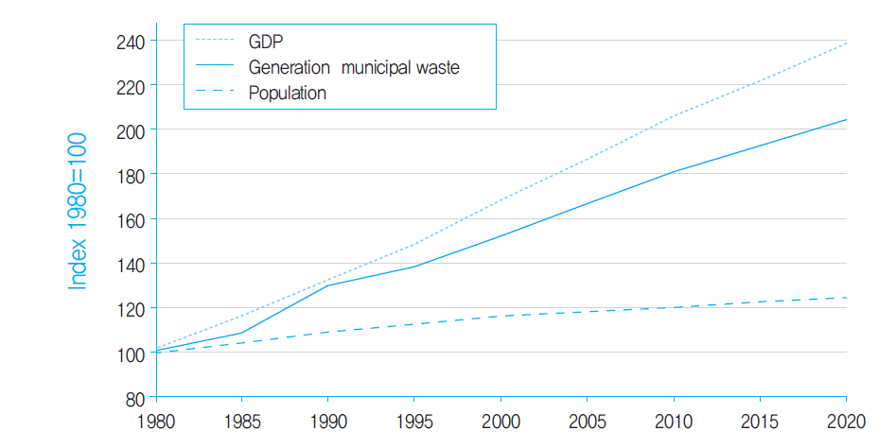

Waste Management Process Change Following VBWFS Enforcement

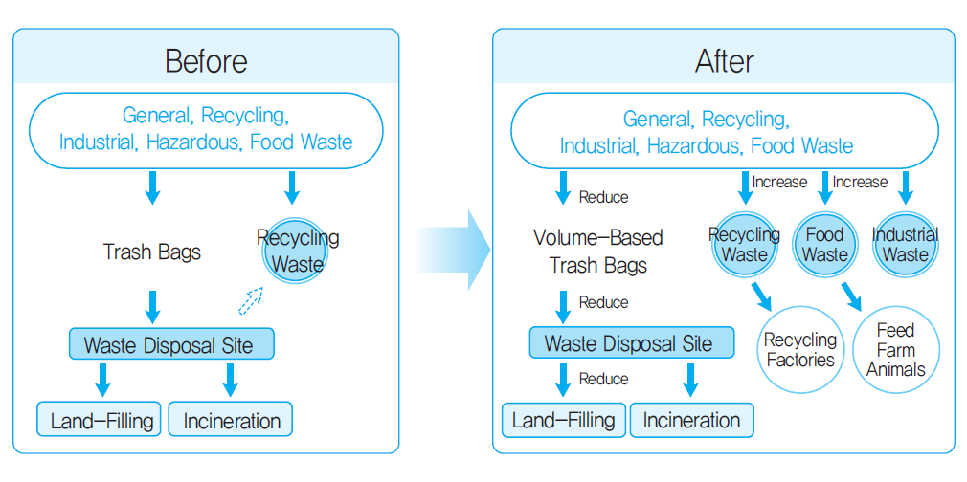

The Amount of Waste Generated and Recycled in Korea, 1994~2004

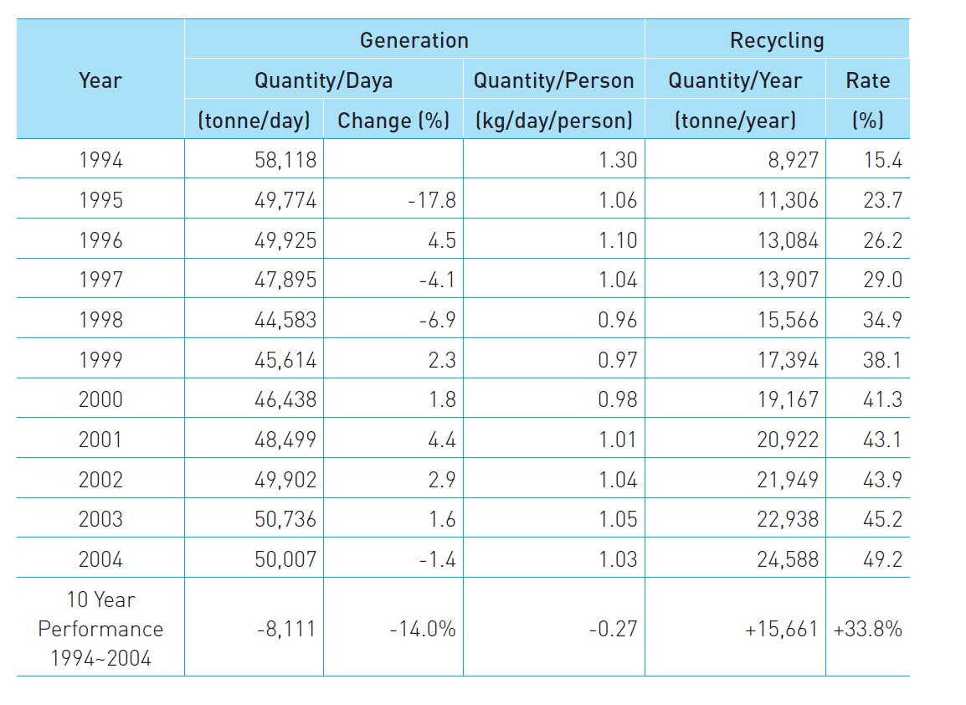

Increase of Budget for Environmental Sector

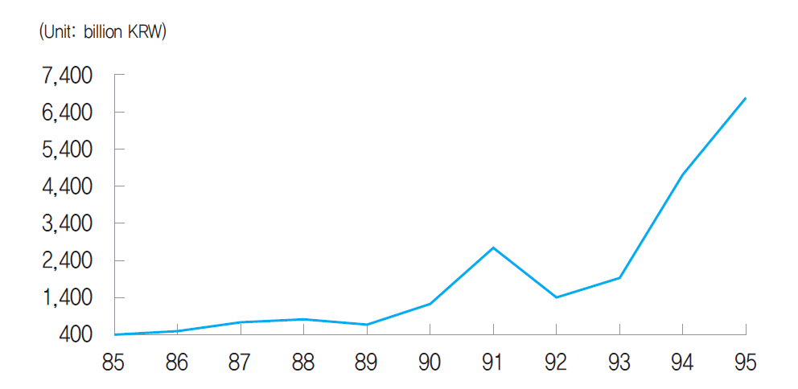

Lifestyle of Korean and Consumers’ Awareness

|  |  |
| --- | --- |
| Consumer’s Awareness | Living |
| - Conspicuous and over consumption  - Sensitive on trend and aesthetic sense  - Consumer conformity  - Design, appearance, brand | - Prefer apartment  - Younger generation (city) and Older generation (house with garden)  - Regard on environment  - Prefer wide-space  - Raising concern on house interior |

|  |  |
| --- | --- |
| Food | Clothes |
| - Freshness, Brand  - Gourmet dinning  - Well-being food | - Colour and design > practical use  - Fashion and style  - Brand consciousness |

Waste Generation in Korea

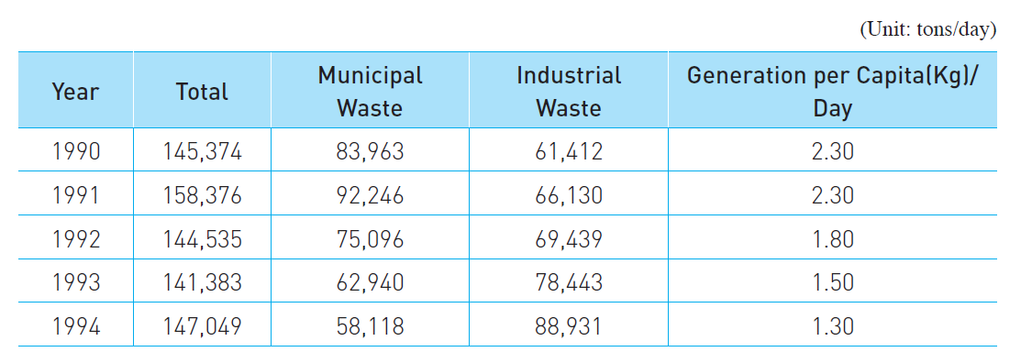

Trend of Recycling by Year

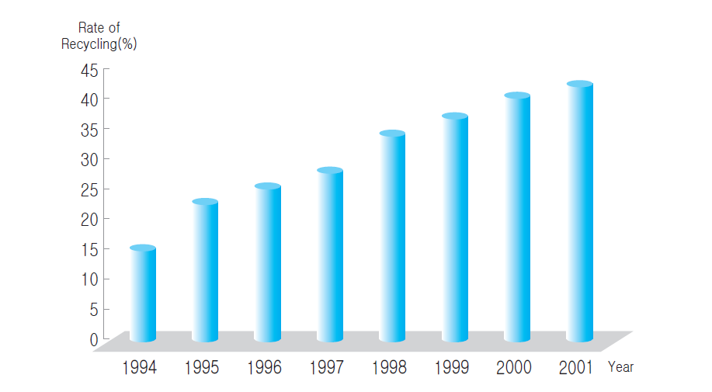

Cases of Illegal Dumping Nationwide

